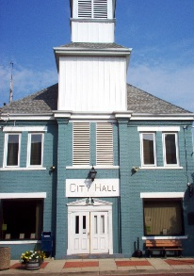
Village of Minerva
209 North Market St.
Minerva, OH 44657
Ph: 330-868-7705
Permit Number: ___________

Property Owner: __________________________________________________________________

Address: ________________________________________________________________________
Zoning District: ____________________ Lot Size: __________________________
Pool Dimensions: _________________________________________________________________
Type of Pool: Round _____ Oval _____ Rectangular _____ Other _____
In Ground __________ Above Ground _______
Capacity of pool (in gallons) _______________
Depths of pool at deepest point ___________
Is the pool fenced in: _______________ (Village Ordinance states that in ground pools must have a 4-7 foot fence. Above ground pools 4 feet or greater in height do not require a fence as long as the ladder or steps or means of ingress are able to be removed or secured to prevent access when not in use. Fences must be equipped with a self closing, latching gate.)

Signature of Applicant: ____________________________________ Date ___________________

Fence: Required __________ Not Required __________
Reason fence not required, if applicable: ________________________________________________

Approved __________ Denied __________

____________________________________________________________________________________ Village Adminstrator Date

Diagram of lot and pool location: Must include distance in feet from property lines. No pool shall be less than 7 feet from any side or rear property line. No pools are permitted in front or side yards. Pool must be constructed so that drainage is not a nuisance to adjacent property owners. Please indicate location of fence if required.

